SECTION 2: INTRODUCTION TO LOCAL ECONOMIC DEVELOPMENT

INTRODUCTION

The purpose of this section is to introduce and explain the purpose and relevance of Local Economic Development (LED) as a vehicle of poverty alleviation and empowerment through job creation. LED has become increasingly important over the past few decades because of the following reasons:

- LED improves the quality of life in impoverished communities
- LED strives to transform market failures into feasible business opportunities
- LED contributes to the elevation of extreme poverty and hardship
- LED uplifts the average income levels of communities
- LED strengthens the ability of local authorities to improve their service delivery function.

WHAT IS LOCAL ECONOMIC DEVELOPMENT

LED is about communities continually upgrading their investment climates to improve their competitiveness, retain jobs and improve incomes. Local communities respond to their LED needs in many ways. There are a wide variety of LED initiatives including:

- Ensuring that the local investment climate is functional for local businesses
- Supporting small and medium sized businesses (SMEs)
- Encouraging new enterprise establishment
- Attracting investment from elsewhere (within the country and internationally)
- Investing in physical (hard) infrastructure
- Investing in soft infrastructure (including human resource development, institutional support systems and regulatory issues)
- Supporting the growth of particular business clusters
- Targeting particular parts of the city for regeneration or growth (spatial targeting)
- Supporting survivalist (often informal) businesses

Local Economic Development (LED) is an outcome, based on local initiative and driven by local stakeholders. It involves identifying and using local resources, ideas and skills to stimulate economic growth and development. The aim of LED is to create employment opportunities for local residents, alleviate poverty, and redistribute resources and opportunities to the benefit of all local residents.

It is important to realise that LED is an ongoing process, rather than a single project or a series of steps to follow. LED encompasses all stakeholders in a local community, involved in a number of different initiatives aimed at addressing a variety of socio-economic needs in that community.

Local economic development initiatives always take place in the context of the national and global economies. Changes in the national and global economy impact on local economies in different ways. For example, a fluctuation in global gold prices may mean that a gold mine, which is the main employer in a small town, is closed down, resulting in high unemployment (i.e. Matjhabeng Local Municipality). LED initiatives need to take account of the national and global context, and be designed in a way, which assists local areas to respond to the national and global contexts creatively.


There is no single approach to LED, which will work in every local area. Each local area has a unique set of opportunities and problems, and must develop an LED strategy (or combinations of strategies) that is relevant to the local context.

For example, some local areas have physical features (such as a beautiful coastline, or close proximity to a harbour or airport), which can be used as resources for LED. Other local areas may draw on different resources for LED, such as money, land or infrastructure, or a skilled workforce. Good relationships, enthusiasm and commitment are also important resources for LED.

LED is not:

- LED is not an industrial policy. It is also not SMME promotion, though SMME may be part of LED.
- LED is not regional planning. Planning can make an important contribution to LED. But while there is often economic development without anybody having planned for it, the process of planning does not secure that there is subsequent economic dynamism.
- LED is not community development. Community development is about solidarity – it is about self-help groups, mutual assistance and voluntary work to help the disadvantaged and solve health, education, housing and other problems.

LED occurs when a local authority, business, labour, NGO’s and most importantly individuals strive to improve their economic status by combining skills, resources and ideas.

KEY CONCEPTS

Local economic development is based on various key concepts. These consist of the following:

- Zone of Action

A specific zone where the local economic development programmes can intervene where it is implemented for maximum benefit.

- Building Community Level Institutions for Development

Planners must incorporate locally relevant institutions and organisations in order to achieve the following:

      - Include those actors that can effect change
      - Represent public and private sector interests
      - Find capital and resources needed as the base for economic development

- Local Ownership Stimulation

Create or retain existing ownership in a community

- Linking Employment and Economic Development Policies and Programmes

Diversify the local economy to provide employment for the existing local human resource base.

- Building Quality Jobs

This in an important priority to improve the living standards in the community. Job creation aimed at increasing the potential for the local population to have secured jobs and income, which stabilises the community both economically and socially.

- Public/ Private Venturing

Combining public sector and private sector resources to attain the objectives neither could obtain alone.

OVERVIEW OF LED STRATEGIES

There is a wide range of different local economic development strategies. Most strategies tend to fall under the following general headings (Blackley, 1989 & Ntsika, 2000).

MARKET LED BASED STRATEGY BASED ON BUSINESS DEVELOPMENT STRATEGY

The Locality Development Strategy Option (built environment)

- Develop a programme to upgrade localities for industrial and commercial uses.
- Develop infrastructure and services.
- Upgrading poor urban areas (townships and inner city areas).

The Business Development Strategy Option (labour demand)

- Find ways to encourage new businesses, to attract existing businesses to the area and to sustain and expand existing local firms.
- Support small businesses.
- Marketing the advantages of a community to the outside world.
- To provide investment in particular high priority sectors likely to produce jobs.
- Local purchasing and servicing arrangements to ensure that where possible, money does not “leak” out of the locality unnecessarily.

BOTTOM – UP OR MARKET CRITICAL APPROACH BASED ON COMMUNITY DEVELOPMENT

The Human Resource Development Option (labour supply)

- Increase specialised training, in order that the local labour market is qualified to work in local businesses and industry.
- Providing information and advice services to business and to job-seekers.

Community-based Employment Development Strategy Option (neighbourhood dimension)

- To create economic development at neighbourhood/ small community level.
- Create employment for persons who are long-term unemployed.

The above strategies are not mutually exclusive or ‘stand alone’ strategies. The strategies work best when linked together; indeed all strategies have links to business development, either existing or new businesses.

WHY DO WE NEED LED?

LED is important because it:

- Creates jobs and new employment opportunities; increases income levels and enable people to pay for services;
- Broadens the tax and revenue base of a local authority;
- Enables the local authority to:
      - Provide more and better services and facilities,
      - Concentrate on human resource potential
      - Concentrate on opportunities for development,
- Promotes linkages between developed and under-developed areas; and builds new institutions for sustainable economic development.

THE LED PROCESS

LED forms an integral part of the IDP, which is a process through which the municipality prepares a strategic development plan. It draws together all the developmental objectives of a municipality including LED, and formulates strategies to realise those objectives in an integrated manner. By drawing together the development priorities, objectives, strategies and budgets in this way, the IDP helps to ensure coordination between LED and other initiatives of government.

It is important to note that the IDP process is the single, inclusive planning process within which other processes must be allocated. LED must be fully integrated within the IDP. A significant amount of resources for the implementation of projects lie with the sector departments (Department of Strategic and Economic Growth; Department of Finance; Department of Technical Services; Department of Community Services; Department of Corporate Services; Public Relations Officer). The IDP provides guidance to sector departments as to where their services are required and hence where to allocate resources at local government level.

The implementation cycle of the LED is made up of four distinct phases. Diagram 2.1 presents the sequence of activities. During the planning stage performance indicators are formulated to monitor implementation and project impacts. The monitoring of projects may result in the adjustment of the plan and therefore the implementation programme.

Diagram 2.1: The LED Process
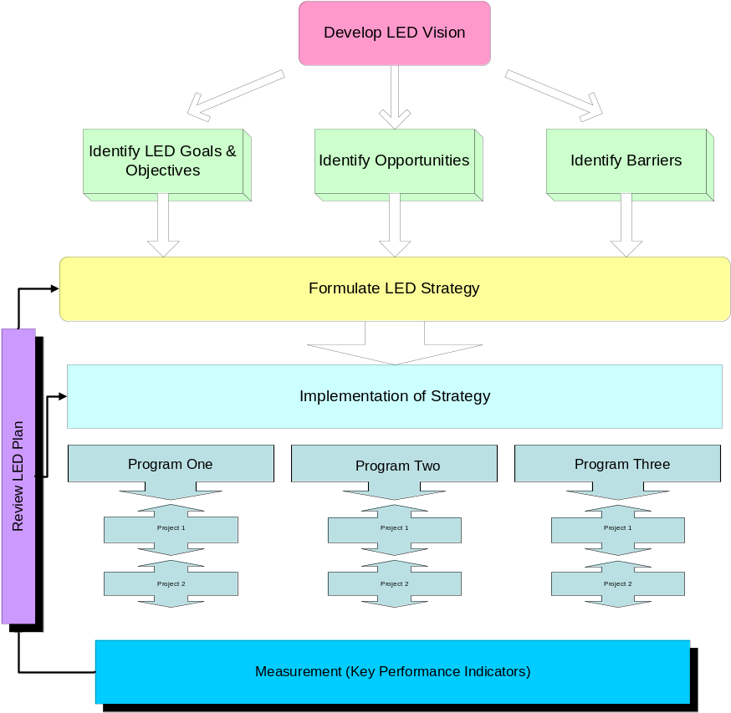
Phase 1
Phase 2
Phase 3
Phase 4

CONCLUSION

Local Economic Development (LED) is an important tool for the development of sustainable local economies and for local economic growth. It is therefore also the tool that can be used to unlock economic opportunities in Makhado that will create jobs and uplift the livelihoods of the people in the Study Area. This, however, can only be achieved if everyone gets involved and a culture of Local Economic Development is established among the members of the community, the Local Municipality and the private sector.

The LED Plan will be based on identified development needs, opportunities and comparative advantages to inform and guide the Municipality to facilitate development, unlocking the latent economic development potential, encourage private sector investment and create economic development and job opportunities for the poor.

